Planned Giving Reprintables

WELS Ministry of Christian Giving has edited and approved the following resources for your church to customize (when necessary) and use as needed. They are intended to encourage members about good stewardship practices and to inform them about ways to make planned gifts to benefit your church and other WELS ministry. Consider using them at your website, in bulletins or newsletters, etc. To use, modify as you’d like. Then highlight the text and copy and paste it (Ctrl-C, Ctrl-V) where you want it to go.

The first resource is from Stewardship Advisors. To learn more, visit stewardshipadvisors.org or call Ron Chewning at 888-783-2790. WELS Ministry of Christian Giving obtained permission to share this.

WE WANT TO KEEP OUR MONEY IN
SUBJECTION AND NOT LET
IT BECOME OUR MASTER.

“No one can serve two masters. Either you will
hate the one and love the other, or you will be
devoted to the one and despise the other. You
cannot serve both God and money”
(Matthew 6:24).

AS SALT, OUR HIGHEST RESPONSIBILITY
IS TO REACH LOST SOULS BY BRINGING
THEM THE SAVING GOSPEL OF CHRIST.

“You are the salt of the earth. But if the salt
loses its saltiness, how can it be made salty
again?” (Matthew 5:13).

HARD WORK AND AMBITION ARE
COMMENDABLE CHRISTIAN VIRTUES,
BUT WE MUST BE CAREFUL NOT TO
ALLOW THEM TO BECOME SINFUL
OBSESSIONS.

“Whatever you do, work at it with all your
heart, as working for the Lord, not for human
masters” (Colossians 3:23).

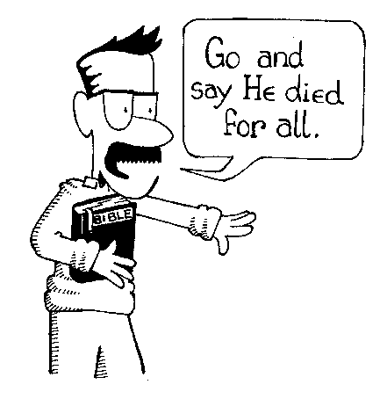
GOD GIVES US THE PRIVILEGE OF
SERVING AS HIS MESSENGERS TO
MAKE THE GOSPEL KNOWN TO
PEOPLE ALL OVER THE EARTH.

“Go and make disciples of all nations,
baptizing them in the name of the Father
and of the Son and of the Holy Spirit and
teaching them to obey everything I have
commanded you” (Matthew 28:19).

One Size Fits None

If you have even a generic estate planning document in place, such as a will, you are in a better position with your plans than most people, since less than half of people even have a will. However, you are a unique individual, and one size does not fit all when it comes to estate planning. There is no one like you with the exact same possessions and plans to provide for your family and the Lord’s work after you’re with our Lord.

That is why WELS offers the services of local Christian giving counselors to help each household prepare a multi-faceted estate plan covering their personal situation and goals. A giving counselor can help you consider things you might not have thought about. Once he works with you to determine the specifics of what you would like done, he can help you find a reputable, Christian estate planning attorney near you who will take care of the final steps of making your plans official.

In addition, WELS offers a booklet titled, “Estate Planning for the Christian Steward,” to help you prepare for your meeting. Topics include writing a Christian preamble, considering the people in your life and the blessings God has given you, and determining your planners. There are tear-out forms you can use to provide your planners and your family with all the information they need.

This is all available to you at no cost or obligation. The goal is to assist fellow Christians with formally documenting their wishes to support their families and the Lord’s work. To receive a copy of the estate planning booklet or to speak with our congregation’s Christian giving counselor, call WELS Ministry of Christian Giving at 800-827-5482.

