Planned Giving Reprintables

WELS Ministry of Christian Giving has edited and approved the following resources for your church to customize (when necessary) and use as needed. They are intended to encourage members about good stewardship practices and to inform them about ways to make planned gifts to benefit your church and other WELS ministry. Consider using them at your website, in bulletins or newsletters, etc. To use, modify as you’d like. Then highlight the text and copy and paste it (Ctrl-C, Ctrl-V) where you want it to go.

The first resource is from Stewardship Advisors. To learn more, visit www.stewardshipadvisors.org or call Ron Chewning at 888-783-2790. WELS Ministry of Christian Giving obtained permission to share this.

ONLY WITH GOD’S STRENGTH,
CAN WE DENY SELF, DO HIS
WILL, AND FOLLOW HIM.

“Then Jesus said to his disciples, ‘Whoever
wants to be my disciple must deny themselves
and take up their cross and follow me.’”
(Matthew 16:24).

ONE OF THE HARDEST AREAS
TO ALLOW GOD TO HAVE
CONTROL OVER IS OUR FINANCES.

“So if you have not been trustworthy in
handling worldly wealth, who will trust
you with true riches?” (Luke 16:11).

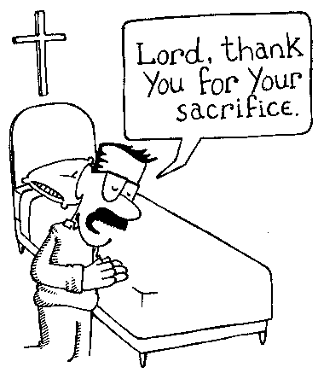
LET CHRIST’S SACRIFICE MOVE
YOU TO LOVE AS HE LOVED, TO
GIVE YOURSELF AS HE GAVE.

“Be imitators of God, therefore, as dearly
loved children and live a life of love, just
as Christ loved us and gave himself up
for us as a fragrant offering and sacrifice
to God” (Ephesians 5:1).

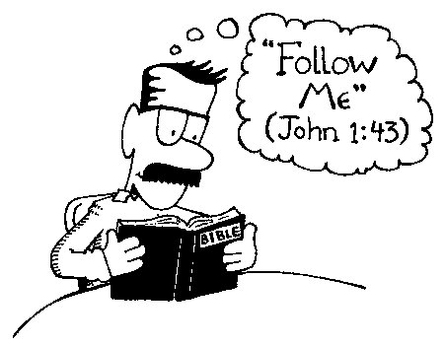
IDOLATRY IS PUTTING
SOMEONE OR SOMETHING
BEFORE GOD.

“Love the Lord your God with all
your heart and with all your soul and
with all your mind and with all your
strength” (Mark 12:30).

Every Check a Reminder

WELS Foundation’s gift annuity program, which benefits WELS ministries such as our congregation, appeals to donors for several reasons.

First, the annuity payments are fixed and unaffected by the ups and downs of market conditions. You can count on receiving the same amount on every payment date.

Second, the payment rates are very attractive, especially for older donors.

Third, the payments last a lifetime. It doesn’t matter how long you live, your payments will keep right on coming.

Fourth, part of the payment amount is tax-free. This benefit lasts until you reach the normal age of life expectancy.

Fifth, you receive an income tax deduction when you obtain the annuity, and your estate may benefit by having the asset removed from possible estate taxes.

Sixth, your gift annuity provides you with immense satisfaction, knowing that you have made a significant gift to the Lord.

Seventh, your gift annuity is a powerful example to family and friends that you value your congregation and what it represents.

Annuitants (those who receive payments from annuities) receive their annual payments on a quarterly basis. This means that every three months they either receive a check or a notice that funds have been deposited in their account. These quarterly payments can serve as a reminder of the benefits of having a charitable gift annuity.

To learn how you can obtain your own gift annuity through WELS Foundation contact Christian giving counselor [counselor name] at [counselor contact information]. He can share with you helpful information and provide a personalized illustration showing what a gift annuity can mean for you. There is no cost or obligation for the consultation.

