Mission and Ministry Sunday

BIBLE STUDY LEADER’S GUIDE

Daniel’s Dream of a Multiracial and Multilingual People in Heaven

Introduction:
On August 28th, 1963 Dr. Martin Luther King, Jr. gave his famous “I have a dream” speech. What was Dr. King’s dream? Why is his dream actually impossible to attain in our world?

Key quotes from Dr. Martin Luther King’s “I have a dream” speech:
“I have a dream that little children will one day live in a nation where they will not be judged by the color of their skin, but by the content of their character."
"I have a dream that one day on the red hills of Georgia the sons of former slaves and the sons of former slave owners will be able to sit down together at a table of brotherhood."
"This is our hope. This is the faith that I go back to the South with. With this faith we will be able to hew out of the mountain of despair a stone of hope. With this faith we will be able to transform the jangling discords of our nation into a beautiful symphony of brotherhood. With this faith we will be able to work together, to pray together, to struggle together, to go to jail together, to stand up for freedom together, knowing that we will be free one day."
His dream is impossible to achieve in our world because we are by nature dead in sin and enemies of God. As a result of sin racism, bigotry, and hate will always take place in our world.

Daniel had a beautiful vision in which Spanish speakers, English speakers, Vietnamese speakers, black people, red people, and all people under the sun would be together in heaven. Daniel’s dream will come true because of the victory of the Son of God, but not without great challenges first.

Part I: The Challenges in Daniel’s Dream

Read Daniel 7:1-7 – Past Challenges for God’s People
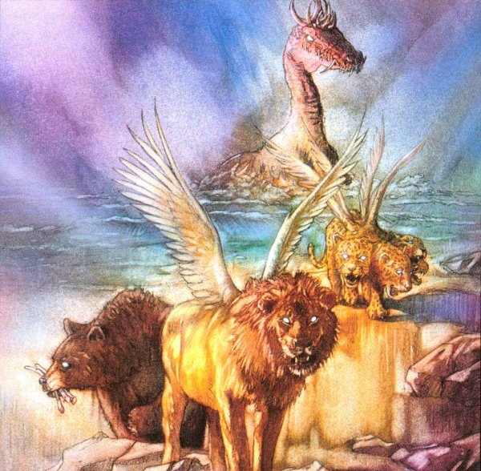
- Daniel here describes four beasts. From your knowledge of secular and biblical history, indicate each beast according to its fulfillment in history.

a. The Winged Lion –

The winged lion in Daniel’s dream represents the Babylonian Empire and King Nebuchadnezzar. The wings of the lion show the speed with which the empire could attack.

b. The Bear –

The bear represents the Medo-Persian Empire. The bear is raised on its side to show that the Persian group enjoyed greater power in the relationship found in the Medo-Persian Empire. The three ribs in its mouth represent the three kingdoms conquered by the Medo-Persian Empire: 1) Lydia, 2) Babylon, and 3) Egypt.

c. The Leopard –
The leopard represents the Greek Empire of Alexander the Great. He quickly conquered much of the known world, but later, after his death, the empire was divided into four parts as is predicated by the four heads of the leopard. The four parts were Macedon and Greece, Thrace and Asia Minor, Syria, and Palestine and Egypt.

d. The Terrifying Beast –
The fourth beast seems to indicate the Roman Empire.

Read Daniel 7:8, 19-25 – Present Challenges for God’s People

- List the characteristics of the little horn in Daniel’s vision?
- Came up among the ten horns
- Uprooted three of the horns
- Eyes of a man
- Spoke boastfully
- Slain and destroyed
- Wages war against the saints and defeats them
- Speaks against the Most High
- Oppresses the saints
- Tries to change the set times and laws
- The saints are handed over to it
- Power is taken away

- Explain why the little horn was more terrible than all the other the beasts in Daniel’s vision.

This little horn wages war against the saints, oppresses them, and even defeats them at times in the vision. Can anything be worse than saints falling from the faith?

- What is the most antichristian statement you can possibly make? Who is making those statements today?

The most antichristian statement you can make is that salvation is by faith and works. Some might claim that statements condemning Christianity or statements making fun of Christianity are worse. However, these statements are not cloaked in lies or in a false veneer that Christ is everything for us. The first statement is worse because Christians might actually believe the lie and go to hell as a result. Furthermore, the first statement is a direct assault on Christ’s principle work of justification, which is by grace alone through faith alone.

- Daniel’s dream troubled him and his face turned pale (verse 28). What are some of the truths in Daniel’s dream that scare us?

The truth that some saints are being defeated in Daniel’s dream is the most terrifying. There is nothing more terrible than a Christian losing his or her faith. Daniel’s vision again brings us to the realization that we are at war with the forces of evil in this world.

- Daniel’s dream is finding fulfillment today. We are at war with very dangerous enemies. How do you find evidence of that in your own personal life? In your church? In your synod?

Answers may vary, but could include:

We see the devil’s power in our own lives as we struggle against sin and lose the struggle. We fail our God, families, and our friends. We see our enemies win victories over the church as infighting occurs, as we struggle to do outreach, and even as churches become lazy in their mission. We see the effects of the war on our synod as we lose members and as churches cannot support the synod’s mission.

Part II: The Final Victorious Kingdom

Read Daniel 7:9-14

- Describe the final kingdom of the world.

The Ancient of Days/the Son of Man will have an everlasting dominion over a kingdom that will never be destroyed.

- Who is the person in verse 13? How do you know?

The person in verse 13 is the Son of Man or the Christ. He is the victorious Savior of the world taking his rightful place at the right hand of God himself. We know this from Jesus constantly calling himself the “Son of Man,” a clear reference to Daniel 7. We also find similar descriptions of Christ in the New Testament. For example, in Philippians 2, the apostle Paul describes the Christ in the same way Daniel did here.

- What great comfort do these verses give to you? To your church? To your synod?

The comfort that we receive here as individuals, churches, and as a synod is that the Son of Man will give us the victory in the end.

- Two great truths repeat themselves in Daniel chapter 7: 1) There will be great war and difficulty for the saints. 2) The Savior, with the saints, will triumph in the end. How do both truths impact the work we do together in the Wisconsin Synod?

Our work together in the Wisconsin Synod will never be perfect. We will fail at times. We will succeed at times. We will struggle against the enemies of the church at all times. However, after great battle, the saints will triumph.

Part III: Application

Discussion Questions for Daniel 7:

- Why do soldiers often fight side-by-side in war? Keeping in mind Daniel 7, why is it good for our congregation to work together with other congregations in the Wisconsin Synod?

Soldiers fight side-by-side because alone each one would be very vulnerable. Together soldiers are stronger, safer, and more willing to stand and fight. It works the same for our congregation. Without the prayers, encouragement, and support of other congregations it would be much easier to give up. However, together we are stronger, safer, and more eager to do battle.

- Compare and contrast Daniel’s vision and Dr. Martin Luther King’s dream. Consider Daniel 7:14, “He was given authority, glory, and sovereign power; all peoples, nations, and men of every language worshipped him.”

In many ways, the prophet Daniel had dreams similar to those of Dr. Martin Luther King. Both saw a place where all people treated each other as equals and where race and language were no longer issues. Daniel’s dream differs from Dr. King’s dream in significant ways as well. Daniel’s dream had to do with heaven itself, a lofty dream indeed. Dr. King’s focus was to change society. Daniel’s dream was not just about social change, but spiritual rebirth through Word and sacrament for all kinds of people so that they could enjoy the blessings of heaven itself.

- Agree of disagree? The Wisconsin Synod is doing a good job working toward Daniel’s vision of a multiracial and multilingual heaven.

Agree. The Wisconsin Synod is doing mission work in many countries around the world in many different languages. The Wisconsin Synod is also reaching out to all races and languages here in the United States. Sure Foundation Lutheran Church, Woodside, N.Y., is a great example of the Wisconsin Synod’s efforts in cross-cultural mission work. Sure Foundation is located in the most diverse community in the world. Sure Foundation has worship services in two languages and membership of people from 11 nations in the world.

- How will this Bible study change your support of your fellow Christian, your church, and your synod?

I will redouble my effort in prayer. I will examine my own giving to see if I can do more. I will encourage my congregation to also support the synod through its Congregation Mission Offerings.

