Mission and Ministry Sunday

BIBLE STUDY

Daniel’s Dream of a Multiracial and Multilingual People in Heaven

Introduction:
On August 28th, 1963 Dr. Martin Luther King, Jr. gave his famous “I have a dream” speech. What was Dr. King’s dream? Why is his dream actually impossible to attain in our world?

Like Dr. King, Daniel had a beautiful vision in which Spanish speakers, English speakers, Vietnamese speakers, black people, red people, and all people under the sun would be together in heaven. Daniel’s dream will come true because of the victory of the Son of God, but not without great challenges first.

Part I: The Challenges in Daniel’s Dream

Read Daniel 7:1-7 – Past Challenges for God’s People
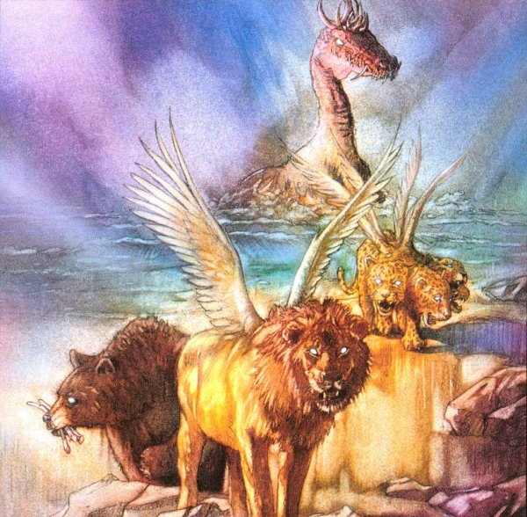
- Daniel here describes four beasts. From your knowledge of secular and biblical history, indicate each beast according to its fulfillment in history.

a. The Winged Lion –

b. The Bear –

c. The Leopard –

d. The Terrifying Beast –

Read Daniel 7:8, 19-25 – Present Challenges for God’s People

- List the characteristics of the little horn in Daniel’s vision?

- Explain why the little horn was more terrible than all the other the beasts in Daniel’s vision.

- What is the most antichristian statement you can possibly make? Who is making those statements today?

- Daniel’s dream troubled him and his face turned pale (verse 28). What are some of the truths in Daniel’s dream that scare us?

- Daniel’s dream is finding fulfillment today. We are at war with very dangerous enemies. How do you find evidence of that in your own personal life? In your church? In your synod?

Part II: The Final Victorious Kingdom

Read Daniel 7:9-14

- Describe the final kingdom of the world.

- Who is the person in verse 13? How do you know?

- What great comfort do these verses give to you? To your church? To your synod?

- Two great truths repeat themselves in Daniel chapter 7: 1) There will be great war and difficulty for the saints. 2) The Savior, with the saints, will triumph in the end. How do both truths impact the work we do together in the Wisconsin Synod?

Part III: Application

Discussion Questions for Daniel 7:

- Why do soldiers often fight side-by-side in war? Keeping in mind Daniel 7, why is it good for our congregation to work together with other congregations in the Wisconsin Synod?

- Compare and contrast Daniel’s vision and Dr. Martin Luther King’s dream. Consider Daniel 7:14, “He was given authority, glory, and sovereign power; all peoples, nations, and men of every language worshipped him.”

- Agree of disagree? The Wisconsin Synod is doing a good job working toward Daniel’s vision of a multiracial and multilingual heaven.

- How will this Bible study change your support of your fellow Christian, your church, and your synod?

