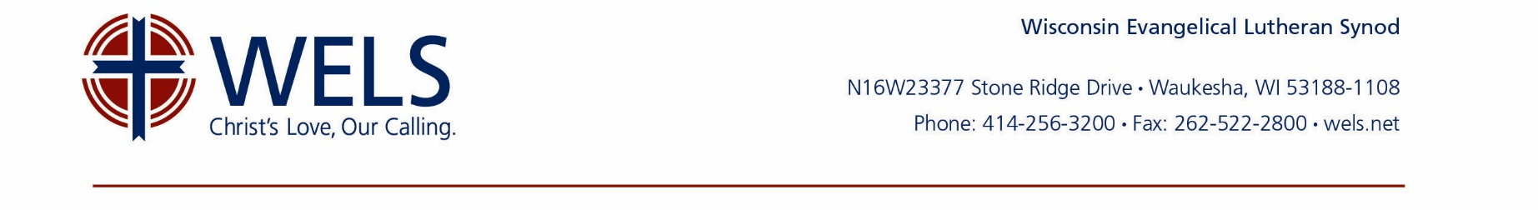
IRA Charitable Distribution Acknowledgment Letter Template

The following letter template can be used to acknowledge IRA charitable distributions received in support of your organization’s ministry.

[Date]

[Donor Name]
[Donor Address]

Dear [Donor Name],

Thank you for your [year] IRA qualified charitable distribution in the amount of [$x.xx] received at our office on [date]. Per your direction, the gift will be used to support [Name of Ministry].

We are writing to acknowledge that we received check [#] directly from [Company Name], your plan trustee/administrator, and that it is your intention for all of your gift to qualify as a qualified charitable distribution from your IRA, as provided under Protecting Americans from Tax Hikes Act of 2015 (H.R. 2029) and Section 408(d)(8) of the Internal Revenue Code.

In that connection, we affirm that our organization is qualified under section 170(b)(1)(A) of the Internal Revenue Code. Your gift was not transferred to a donor-advised fund or a supporting organization or any other funds for which donors or their designees have further advisory rights.

We further affirm that no goods or services or benefits of any value were or will be transferred to you in connection with this gift.

Please retain this letter with your tax documents and provide a copy to your tax preparer. While you undoubtedly reviewed pertinent information and sought professional counsel while arranging this gift, it is important for WELS to remind you that there are limits to the amount of qualified charitable distributions that can be made from an IRA each year and that gifts within this limit do not qualify for a charitable deduction.

If you have any questions, please contact me as needed.
Together in Christ,
[Signature of official]

