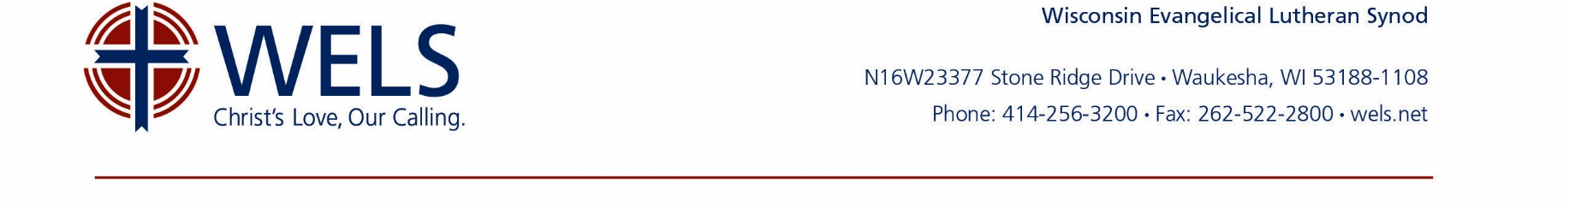
Sample Church Gift Acceptance Policy
On behalf of [Congregation Name], and under the direction of the voters assembly/church council, the Board of Stewardship/special gifts committee/financial secretary [or another officer] shall be responsible for overseeing gifts offered with donor-imposed restrictions. These include memorials, estate gifts, and gifts other than cash or marketable securities (hereafter referred to as “special gifts”).

- Special gifts will be reviewed by the Board of Stewardship/special gifts committee/financial secretary [or another officer] at their regularly scheduled meetings. When needed, special meetings may be called or written communications (including e-mail) may be used to review special gifts.

- Special gifts not restricted by the donor will be distributed in accordance with the congregation’s prevailing unrestricted gifts policy [for example, "50% debt retirement, 30% ministry plan, 10% WELS, and 10% Scholarship Fund”—the policy should be reviewed periodically so that it continues to correspond with the church’s mission, vision, and priorities].

- Unless earmarked for an existing fund or project, donor-restricted gifts must be accepted by the Board of Stewardship/special gifts committee/financial secretary [or another officer]. Donor-restricted gifts not earmarked for an existing fund or project must be sufficient to fully fund the new proposed project. If accepted, the gift must be used in accordance with the accepted restrictions and the restrictions must be documented. The Board of Stewardship/special gifts committee/financial secretary [or another officer] will keep a log of accepted restricted gifts that includes appropriate gift information, such as donor names, gift descriptions, dates received, how gifts were acknowledged, the specific restrictions on the use of gifts, and when and for what purpose the gifts were ultimately dispersed.

- Gifts other than cash or marketable securities must be accepted by the voters at a congregational meeting. Prior to making a non-cash gift, donors are encouraged to discuss their intentions with the Board of Stewardship/special gifts committee/financial secretary [or another officer]. The asset should be readily marketable, unencumbered with debt, free of environmental or other liabilities, and should not require additional funding by the congregation. Examples include but are not limited to the following:
  - Real estate may consist of vacant land, residences, rental, farmland, or commercial property.
  - Privately held assets may include ownership of a business, income property, collectibles, or other items of value.

Exceptions [examples to consider—will vary by congregation]:
        - School supplies and other items intended for school use must be approved by the principal or the chairman of the Board of Christian Education.
        - Materials given for the maintenance and upkeep of the church and/or school facilities must be approved by the chairman of the Board of Trustees.
        - Gifts with a value of less than $250 do not need special approval.

- Marketable securities include assets such as stocks, bonds, and mutual funds. The congregation shall liquidate marketable securities, whether intended for the general operating budget or an existing special fund or purpose, as promptly as reasonably possible. Any transaction fees attributable to the liquidation shall be paid out of the proceeds of the gift.

The chairman (or his designee) of the Board of Stewardship/special gifts committee/financial secretary [or another officer] will communicate decisions to the donor(s).

Requests from donors to remain anonymous shall be respected.

The congregation may use the services of the WELS Ministry of Christian Giving and/or WELS Foundation to assist with the review, acceptance, and liquidation of special gifts.

Approved by the __________ Evangelical Lutheran Church on _____________________, [Year].

