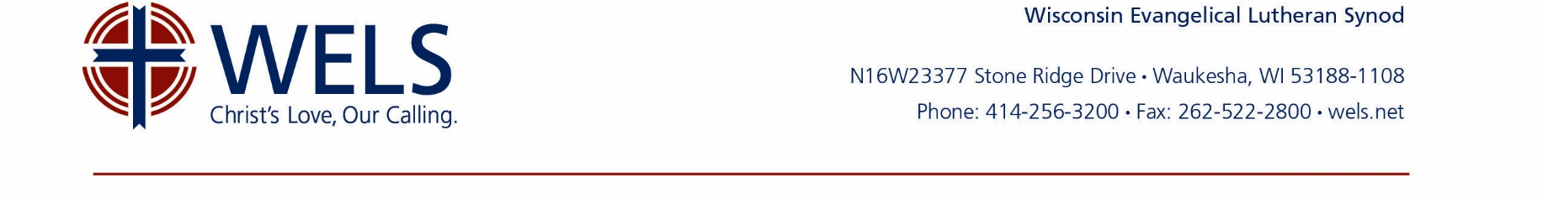
This template is intended as a guide. The congregation should consult with legal counsel. In addition, a congregation should think through how the endowment works in their specific situation, who is responsible for its administration, and how those people are held accountable to the congregation, then edit the document accordingly.

Sample Endowment Fund Wording
for Amending a Congregation’s Bylaws

[Congregation Name] Endowment Fund

Section 1: Definition
The [Congregation Name], [City], [State] Endowment Fund (hereafter referred to as the “Fund”) shall be a permanently restricted fund established to receive and administer all gifts that are designated for the Fund.

Section 2: Purpose
The purpose of the Fund shall be to [insert purpose, e.g., “support the work of the congregation for Christ both in the community and in the world at large.”]

Section 3: Administration
[This Fund can be administered under a congregational planned giving committee, endowment fund committee, or another arrangement determined by the congregation. You will want to review your state’s Uniform Prudent Management of Institutional Funds Act (UPMIFA).]

Congregational Planned Giving Committee:

- The [Congregation Name] Congregational Planned Giving Committee (CPGC) shall consist of [#] members, all of whom shall be members in good standing. The term of each member shall be [#] years. The church council shall appoint [#] members to the CPGC with staggered terms. In the event of a vacancy on the CPGC, the church council shall appoint a replacement member. The congregational treasurer is an [ex-officio or advisory] member of this committee and liaison to the church council. A pastor shall serve as a non-voting, ex-officio member. After a lapse of one year, former committee members may be reappointed.

- The CPGC shall meet at least quarterly. A quorum shall consist of [#] members. The CPGC shall elect from its membership a chairman and recording secretary:
- The chairman shall facilitate all CPGC meetings.
- The recording secretary shall maintain complete and accurate minutes of meetings and supply a copy thereof to each member of the CPGC, the church council, and the pastor(s).
- The CPGC is to plan and carry out an annual program to inform congregation members of the benefits of Christian giving and the purposes of the Fund. It will encourage members of the congregation to meet with Christian giving counselors to discuss their planned gifts. The CPGC will utilize the resources of WELS Ministry of Christian Giving and WELS Foundation.

- The CPGC oversees the [investing and] distribution functions listed below.

Section 4: Gifts to the Fund
All gifts received shall comply with the gift acceptance policy.

Section 5: Investments
All Fund assets are to be managed and invested in good faith and with the care an ordinarily prudent person in a like position would exercise under similar circumstances. [To accomplish this, endowment assets will be invested with WELS Investment Funds.]

Section 6: Distributions from the Fund
To preserve the purchasing power of the Fund while providing financial resources for current operations, the following distribution formula will be used, subject to annual review:

Annually the Fund will distribute four percent of the four-year (or since inception) rolling average market value of the Fund as of [the end of the fiscal year].

Distributions will be announced to celebrate the Lord’s blessings to the congregation through the Fund.

Section 7: Disposition or transfer of the Fund
In the event [Congregation Name] ceases to exist either through merger or dissolution, distribution of the Fund to a successor organization shall be at the recommendation of the church council and by approval of the voters assembly in conformity with non-profit corporation statutes and [Congregation Name]’s constitution and bylaws.

